# **Sessional Assignment – 1**

Parth Vohra 102016044 3CS10

Output:

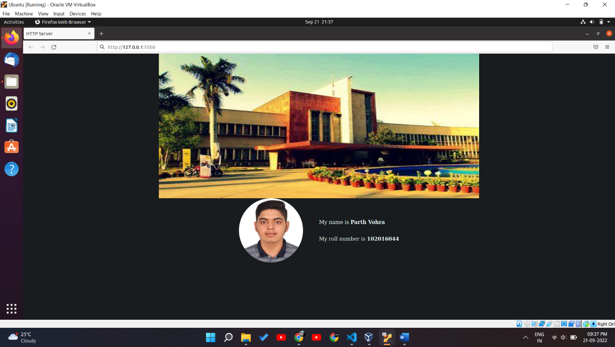

Code:

#include <stdio.h>

#include <sys/socket.h>

#include <unistd.h>

#include <stdlib.h>

#include <netinet/in.h>

#include <string.h>

#include <arpa/inet.h>

#define PORT 5500

int port = 0;

char *path;

void loadConfig(){

    // file contains format like this:

    /*

        PORT=80

        PATH=/var/www/html/index.html

    */

    FILE *fp;

    char *line = NULL;

    size_t len = 0;

    ssize_t read;

    fp = fopen("config.txt", "r");

    if (fp == NULL)

        exit(EXIT_FAILURE);

    while ((read = getline(&line, &len, fp)) != -1) {

        if(strstr(line, "PORT=") != NULL){

            port = atoi(line + 5);

        }

        if(strstr(line, "PATH=") != NULL){

            path = line + 5;

        }

    }

    fclose(fp);

    printf("File is loaded!! :)\n");

    printf("Port: %d\n", port);

    printf("Path: %s\n", path);

}

void setUpServer(char httpHeader[]){

    // file is path + index.html

    FILE *fp;

    fp = fopen(strcat(path, "index.html"), "r");

    if (fp == NULL)

        exit(EXIT_FAILURE);

    char *line = NULL;

    size_t len = 0;

    ssize_t read;

    while ((read = getline(&line, &len, fp)) != -1) {

        strcat(httpHeader, line);

    }

    fclose(fp);

}

int main(int argc, char const *argv[]){

    int server_fd, new_socket; long valread;

    struct sockaddr_in address;

    int addrlen = sizeof(address);

    // Only this line has been changed. Everything is same.

    // give size

    char httpHeader[100000] = "HTTP/1.1 200 OK\r\n\n";

    loadConfig();

    setUpServer(httpHeader);

    printf("Header: %s\n", httpHeader);

    // Creating socket file descriptor

    if ((server_fd = socket(AF_INET, SOCK_STREAM, 0)) == 0)

    {

        perror("In socket");

        exit(EXIT_FAILURE);

    }

    address.sin_family = AF_INET;

    address.sin_addr.s_addr = INADDR_ANY;

    address.sin_port = htons(port);

    memset(address.sin_zero, '\0', sizeof address.sin_zero);

    if (bind(server_fd, (struct sockaddr *)&address, sizeof(address))<0)

    {

        perror("In bind");

        exit(EXIT_FAILURE);

    }

    if (listen(server_fd, 10) < 0)

    {

        perror("In listen");

        exit(EXIT_FAILURE);

    }

    while(1)

    {

        printf("\n+++++++ Waiting for new connection ++++++++\n\n");

        if ((new_socket = accept(server_fd, (struct sockaddr *)&address, (socklen_t*)&addrlen))<0)

        {

            perror("In accept");

            exit(EXIT_FAILURE);

        }

        char buffer[30000] = {0};

        valread = read( new_socket , buffer, 30000);

        printf("%s\n",buffer );

        write(new_socket , httpHeader , strlen(httpHeader));

        printf("------------------Hello message sent-------------------");

        close(new_socket);

    }

    return 0;

}

Website(HTML) Code:

<!DOCTYPE html>

<html lang="en">

  <head>

    <meta charset="UTF-8" />

    <meta http-equiv="X-UA-Compatible" content="IE=edge" />

    <meta name="viewport" content="width=device-width, initial-scale=1.0" />

    <title>HTTP Server</title>

    <link rel="stylesheet" href="index.css" />

  </head>

  <body

    style="

      display: flex;

      align-items: center;

      justify-content: center;

      flex-direction: column;

      margin: 0 0 50px;

      background-color: #181c1e;

      color: azure;

    "

  >

    <style>

      .container {

        display: flex;

        flex-direction: row;

        justify-content: center;

        align-items: center;

      }

      .pfp {

        width: 200px;

        height: 200px;

        border-radius: 100%;

      }

      .container .info {

        display: flex;

        flex-direction: column;

        justify-content: center;

        align-items: flex-start;

        margin-left: 50px;

      }

    </style>

    <img

      src="Thapar.jpg"

      alt="Servatom"

      width="1000"

      height="450"

    />

    <div class="container">

      <img

        class="pfp"

        src="me.jpg"

        alt="alternate text"

      />

      <div class="info">

        <p>My name is <strong>Parth Vohra</strong></p>

        <p>My roll number is <strong>102016044</strong></p>

      </div>

    </div>

  </body>

</html>